Jumbo Opens New Showroom at Palms Mall
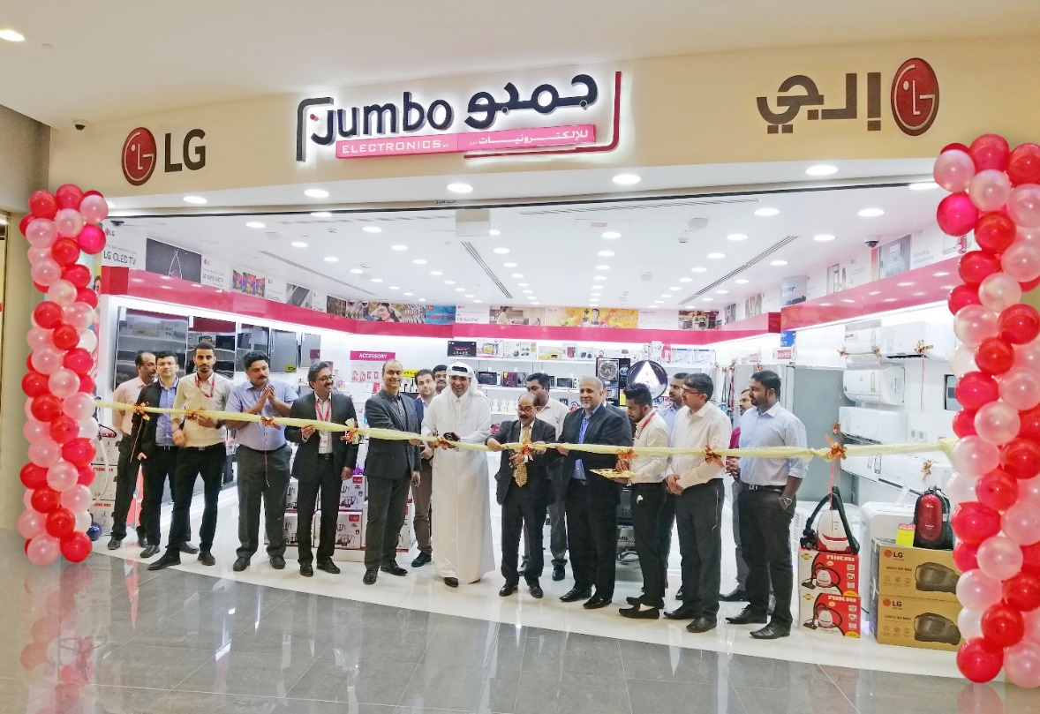
Doha: Jumbo Electronics, the leading consumer electronics retailer in Qatar has expanded its footprint with the opening of a new showroom in Palms Mall on Muiather Street in Al Rayyan. The new showroom of 111 square meters is equipped with a complete range of televisions, audio systems, small & large appliances, air conditioners, smartphones and accessories. A variety of world renowned brands like LG, JBL, Harman Kardon, Indesit, Ariston, Blueair, Morphy Richards, Mr. Light, Brother, Oscar, Awei and many more are available to meet a wide variety of customer needs.

“The store is conveniently located in a neighborhood mall like Palms Mall in Muiather which will offer consumers easy access to world class electronics and appliances. We will continue to expand in areas that will bring our products and services closer to our customers” said Mr. CV Rappai, Director & CEO, Video Home & Electronic Centre/ Jumbo Electronics.
Last month, Jumbo launched ‘Awei’ a leading brand of accessories and last week it launched Blueair Cabin Car air purifier in Qatar. These products will also be available in this showroom. It also began managing the Ooredoo shop in Pearl Qatar as a franchisee outlet from January onwards, thus further strengthening its position as a one stop Total Solutions Provider.

Media Contact
Jumbo Electronics
Leon Lopez
Tel: +974 50458310
Email: leonlopez@jumboqatar.com

